Manual – career guidance in various countries
Project Find Your Right Place in the World of Work was financed from Leonardo da Vinci programme, it is a project of partnership - Vysočina Education /CZ/, Paedagogische Hochschule /AT/, Diocesane Pedagogische Begeleidingsdienst bisdom Brugge /BE/, Chamber of Commerce Jihlava /CZ/, Onisep /FR/ and Stredná odborná škola technická /SK/. We designed this project proposal aiming to increase the quality and impact of career guidance through cooperation and synergy of various agencies providing guidance services at a local level in different countries and we also discuseds this synergy that will create conditions to find own right place in the world of work, through the right choice at the first moment - the most suitable vocational school.

A manual on guidance coordination at the local level was created as a joint outcome of the project.

Which topics should be further elaborated?
- It will be interesting to observe the Austrian way of motivating students to move into technical and vocational training.
- How to promote technical education, avoiding waterfall thinking and taking society’s needs into account?
- How to enhance students’ motivation and improve their attitudes?
- Ways of changing government policy.
- Ways of giving effective feedback to all partners (incl. parents) in the career guiding process
- How to promote language skills, enhancing job opportunities?
- How set up/implement/control and fund guiding and supporting networks. Who does the funding and professional training of career guides? This is particularly a Czech need.
- How are dropouts recovered?
- How can students from vocational education get opportunities in further education?

Vysočina Education - Czech Republic
There are several “key players” in the Czech Republic who are sometimes more coordinated and sometimes work more independently.
The most formal body in the system of counselling is National Educational Institute providing -
- analyses and research related to counselling services in education and educational and psychological aspects of education;
- drafts of legislative and methodological acts regulating a provision of counselling services in education;
- further and continuing education for psychologists, teachers, special pedagogues;
- transfer of scientific information from the fields of psychology, special education, educational-psychological, special-educational and career counselling;
- publication of methodological materials, scientific and informational quarterly journal and other scientific, methodological and informational materials for the use of school counselling authorities, teachers and other people involved in the educational-psychological counselling;
- coordination of mutual cooperation of schools, school facilities, regional autonomy in the area of school counselling provision;
- exchange of experience among the educational-psychological counselling experts;
- cooperation with Czech and foreign experts in the fields of psychology, special education, educational-psychological, special-educational, educative and career counselling, healthcare and social service.
Counselling on school level is very important and requires trained professionals Guidance services in schools means
- educational counsellors - teachers working on a part-time basis as guidance counsellors; methodologically supported by the relevant educational-psychological counselling centre (PPP;)
- school prevention consultant - prevention of risky behaviour;
- school psychologists - reduce the risk of the behavioural and educational problems in children, educational and psychological care provision, counselling, diagnostics;
- special pedagogues - care for pupils with sensory, physical, mental or speech impairment;
- career education - subject matters Vocational choice (primary schools) and Introduction to the world of work (secondary schools);
- School Counselling Centre – a limited number funded by ESF .
Schools closely cooperate with Educational-psychological counselling centres (PPP), schools can ask PPP for a support or parents can contact PPP individually in case problems. PPP provides
- independent counselling facilities securing psychological and special educational services for the children and youth of the 3-19 years age-range;
- services for parents, teachers, and for educators in all nursery, primary and secondary schools;
- the services are focused on psychological care, counselling, and on professional consultations in the issues of personality and educational development of children and youth;
- staff: psychologists, special pedagogues, social workers.
Presently the network of Counselling Centres consists of round 100 state run facilities with the field of action usually in the framework of the appropriate district, of 2 private Counselling Centres, and of 1 church Counselling Centre
In the Czech Republic we can find also Other Educational Counselling Facilities for example:
- Special educational centres (SPC) - counselling and educational care to children and young people with sight, hearing, physical, mental or combined disabilities, and with communication disorders; established since 1990, especially as attached to special nursery and primary schools for children and adolescents with sensory, physical, and mental handicap and for children with speech defects; around 100 facilities.
- Educational Care Centres (SVP) - prevention and the therapy for disaffected children and youth at risk; non-resident and the resident preventive educational care for children and youth with behavioural disorders; established since 1991; at present 28 facilities.
- Information centres for youth (ICM) - information on educational opportunities for all age categories; leisure activities; travelling; prevention; counselling.
- Guidance centres at higher education institutions (HEIs) - at most of faculties and at some of HEIs they were established as a central body for the entire HEI; services for students (possibilities of career development, managing of stress connected with exams etc.) as well as for study applicants (study program information).
Employment Sector cooperates with
- Labour office - department of intermediation - present in all districts; information on unemployed expectants and available work positions, intermediation between employers and job seekers;
- Labour office – department of guidance and professional re-qualifications - a wide range of services from basic advices and information to specific guidance for solving complex problems (including professional diagnostics and psycho-social support);
- Labour office – information and counselling centre (IPS UP) - self-serviced or counsellor-assisted information centre collects information about education offers of all types of schools and private educators as well as about particular occupations and labour market. All types of information can be found there – brochures, PC programs, multimedia, Internet);
- External balance diagnostics centres - expert counselling services for labour office’s clients. Balance diagnostics is tool for overall potential assessment of client and his/her actual possibilities in labour market;
- Personal placement services intermediate work places for their clients (both employers and unemployed expectants).
Other providers and organizations
- Career guidance centre at the National Institute of Technical and Vocational Education (CKP NUOV) provides services for children and their parents as well as for adults aimed at helping with educational and professional choice. It also collects detail information about particular education programs, offer of study programs etc.
- Centre Europass in National institute of technical and vocational education provides information and guidance on support of European mobility in education and labor market and administrates recognition of secondary education across European countries.
- Customer centre at the Institute for Information in Education (UIV) provides wide range of information on educational offer of schools.
- Guidance services support unit (SPPS) focuses on support of guidance services within the labour market sector and monitoring of guidance services in education sector, particularly in higher education.
- Regional information and guidance centres for entrepreneurs (RPIC) provide support and information to people interested in entrepreneurship and in starting their own business and also to current entrepreneurs.
- NGOs offer wide range of career guidance services or assistance for all sorts of target groups (especially for disadvantaged groups of persons).
Examples of a good practises:
- Vysočina Education supports and finances /ESF/ “open houses” schools invite 15 year old pupils to visit technical schools and exchange experiences with peers at secondary schools and learn more about secondary schools;
- seminars and workshops for in-service teachers and school counsellors.

ONISEP Champagne-Ardenne, France

I) How is the French education system organized

- Education is compulsory from 6 to 16 years old.

The architecture:
- Pre-primary school (from 3 to 5: a tradition in France)
- Primary school (from 6 to 10)
- Secondary:
  - Comprehensive school (from 11 to 15)
  - Upper school (general, technological or vocational course) (from 16 to 18)
- Higher education: University, preparatory classes, High schools (general courses)
Secondary schools, University Institutes (vocational courses)

II) The Guidance procedures

- Primary education
There’s no guidance procedure at the end of primary school (free access to secondary comprehensive school).

- Secondary education
The headmaster and council staff have a major role for guidance decision and of the Department of Education for registration in upper secondary schools (presentation of the PAM (« post comprehensive Application” IT system).

- Higher education
Free access to University for every pupil passing « baccalaureate »
Selective entry to any another higher education course
Presentation of the APB (« Post Baccalaureate Application ») IT system.

III) How do schools help young people to find their way to work »

Presentation of some devices implemented in secondary schools and in higher education to help pupils and students to find a vocational path

- In secondary education

For all pupils:
A PDMF (“Program to discover works and courses”) in every secondary school (comprehensive and upper) from second to final year.
Every secondary school has to set “a year program for guidance” under headmaster’s responsibility. Activities are undertaken by teachers mainly, in cooperation with guidance counselors.

For some pupils only:
- A “Work discovery” option (3 hours a week) in final year comprehensive (for 15 years old)
-A “pre-vocational course” final year implemented in vocational upper schools mainly:
“Work discovery” (6 hours a week) including training periods in companies.

In vocational upper schools
Vocational skills are taught in workshops in schools and in companies (compulsory training periods: 22 weeks for a three year course/ 12 to 16 for a two year course)

- In higher education

In general courses
Time for guidance tends to be part of students’ timetable in University.
Each University has a guidance service and many of them have a “professional insertion office”.

In vocational courses
Training periods are full part of the course (10 to 12 in University Institutes / 8 to 16 in Secondary Schools) and time is devoted to work on students’ projects.

IV) The adult vocational training in France

On this field, there are several “key players” in the French adult vocational training.
- A legal financing obligation:
Vocational training for employees is financed by the employers. Companies enterprises of 20 employees and more must spend at least 1.6% of their wages bill on training according to the law.
The Role of the organismes paritaires collecteurs agréés (OPCA) – Approved joint collecting bodies
« Paritaire »: National sectoral bodies (e.g.: OPCA2, OPCA for agriculture cooperatives) ou cross-sector bodies (that can be regional ones, e.g.: OPCAREG: region-based OPCA)
Bodies managed by the social partners
Collecting: They manage the enterprises’ contributions
They also redistribute ≈ as an insurance system
Funds mutualisation
Approved: by the Employment Ministry which authorises them to collect the enterprises’ contributions
- The social partners have a key role:
In the evolution of the continuing vocational training (CVT) system: each major legal reform of the CVT system is initiated by the social partners. They negotiate and sign a collective agreement that is then almost entirely introduced in the law. They really have a prominent role of the social partners in defining training policies in France.
On top of their national negotiating role, French social partners are involved in:
- The choice of training policy for workers in the private sector (Sector-based agreements)
- The management of enterprise training financing (OPCA)
- The management of the training funds for the unemployed / job-seekers (UNEDIC)
- The region and the state share responsibilities
Regions are responsible for the implementation of training for young people and adults (decentralisation initiated in the 80's and achieved in 2004. In France, historically, training beneficiaries (=”publics”) are classified in different crossing categories:
- employees / job seekers
- young people (from 16 to 25) / adults (from 26 to 44 and 45+)
The State still leads fully:
- The Education policy (It guarantees equal access to education: free and non-religious)
- And the Employment policy
It is also responsible for the training of specific publics (disabled people, offenders, refugees, immigrants) and for the training of the civil servants.
- The Continuing vocational Training market
It is a free market. Anyone can create a training body (there are 60 000 enterprises considered as training providers; continuing training is the main activity for 9 100 of them). The market control does not take place a priori (=« at the birth stage ») but a posteriori (=« on the activity »).
A large variety of training providers:
- Private:
- Profit making enterprises;
- Non-profit making enterprises (“associations”);
- Self employed.
- Public (a strong representation of public organisations):
- AFPA training centres from the Ministry of Employment;
- GRETA (a groupment of public educational schools) training centres from the Ministry of Education;
- Agriculture training centres from the Ministry of Agriculture;
- Training centres from the Chambers of Commerce, of Crafts and of Agriculture
- Some original measures for training
Individual training leave - Congé Individuel de Formation (CIF)
This enables any salaried member of staff to follow his/her own choice of training programme during working hours. Such a programme is different to any included in the training plan. On average, such training leave lasts for one year.
During this period, the employee is paid (between 80% and 100% of his basic salary). S/he is also entitled to request that his job be kept open for him in the company.
Staff covered by a fixed-duration contract of employment can also take individual training leave.
Individual Training Right benefit - Droit Individuel de Formation (DIF)
Under the Individual Training Right benefit (DIF), every employee acquires a training-time credit of 20 hours a year within the limits of 6 years, which allows all employees to pursue a vocational training.
Normally, the employee attends training courses outside working hours except when a sector's agreement of the social partners foresees the possibility that the time spent in training is considered as working time. The worker must ask formally to use this right and chooses his/her training session with his/her employer's agreement.
Accreditation of life experience - Validation des Acquis de l’Expérience (VAE)
Obtaining certification: Anyone who can provide proof of having exercised a professional or voluntary activity relevant to the final aim of the desired diploma or qualification can have the knowledge and competencies acquired in the course of that activity accredited in order to obtain all or part of the desired certification, i.e. to be exempted from all or some of the relevant examinations.
Note : Certifications reached through continuous training is fully identical to the ones delivered at initial training level
- The GRETAs under the ministry of national education
Greta is a special network from the national education. (Important to know that each ministry in France has its own training network. E.g ministry of Labour). Greta is A groupment of public educational schools (Un GRoupement d’ETAblissements scolaires publics) that gather skills and technical means to provide adult training.
The main services of a Greta: Training but also counselling and guidance for qualification and employment.
The audience: mainly employees (diversity of people and diversity of financing).
The training: trainings can lead to diplomas from the ‘CAP’ / vocational aptitude certificate : it is the first level qualification, to the ‘BTS’/technician certificate (achieved 2 years after the Baccalaureate), and sometimes vocational post-secondary degrees.

Paedagogische Hochschule - Austria

The Ministry for Women and Education (former Ministry of Education, Arts and Culture) offers a wide range of activities to all schools, institutions and private people all over Austria.
- CG with Migration Background
- Girls Go HTL (gender and science …)
- Girls' Day, Boys' Day
- "Jobs" in elementary education
- Finding your way into the real world of work
- CG bilingual (English: career test, professions and job descriptions, glossary, from school to work - Workbook, game "My Job", Women to the Top …)
- Jobs and Impairments
- Working with parents
- IBOBB (Information, Counseling, Guidance and Orientation for Education and Careers)
The Ministry for Women and Education co-operates with all nine federal boards of education, but is open to all teachers or parents and pupils directly.
The federal boards of education deal with all matters regarding teachers (employment, further education --> PH-NÖ, supervision, legal problems/cases, subject matters, examinations and career guidance).

The Pädagogische Hochschule NÖ develops courses and curricula, addresses and invites teachers of all schools in Lower Austria and cooperates with the LSR (Landesschulrat - federal board of education) as regards training during working times, payment of travelling costs, implementing new things in the schools, information and guidance.

Lower Austria is divided into five regions (Waldviertel, Weinviertel, Mostviertel, Mitte, Industrieviertel), where many courses and seminars of the PH-NÖ in further education are given (mostly in schools there), so that teachers do not have to travel far. Also, there are coordinators for each subject taught (also for career guidance) who regularly go to conferences and meetings in which they are given the latest information and can talk about problems, complaints or success stories.

These coordinators meet with and talk to the regional ‘managers’ and/or the ‘AG-Leiter’ (coordinators of teachers in each subject at a school) and give them the necessary information and support so that they can work with the teachers in their schools.
Anyway, it is not necessary to ‘climb’ this ladder in either direction. Direct contact to any institution mentioned above is possible for certain matters.
In Lower Austria IBOBB seems to work best. The contents of this initiative have been spread in the system as described above.

What we learned in/from the project:

There are a lot of similarities in different countries, but also striking differences.

We would like to have more experts (like the French), also from outside the schools, who can see the pupils and their characters much better. On the other hand we would not want to have parents and pupils without much chance to interfere with the experts’ decisions on what job might be the right one for their child. We are conscious of the fact, though, that there might be problems in the wrong job.

We regard information and practice or at least visits in companies (like the Belgians do) as the best way towards a better understanding of job-life.

In the Czech Republic and also in Slovakia we were impressed by the cooperation between companies and schools. This means a direct way from school into a job and may also influence curricula and timetables in the schools, which are supposed to prepare pupils for real life.

Austria:
Teaching career guidance integrated in compulsory subjects (32 lessons a year) doesn’t seem to be so successful in Austria, as it is often done “quickly”, like a collection of vocabulary or talking “about” job life etc. Personal experience cannot be replaced by any method of teaching like that.
Also, many schools want to keep their pupils for “higher” education, and therefore do not inform pupils sufficiently or are not interested in different possible careers of the students.
We also found out that teaching career guidance as a subject may not only give it more importance, but also more efficiency.

Experts should at least support teachers or, where necessary, replace them.

Diocesane Pedagogische Begeleidingsdienst bisdom Brugge – Belgium

Centrum voor Leerlingenbegeleiding = Pupil Guidance Centre

- 72 CLB in Flemish part of Belgium and Brussels

4 areas of CLB-work
- Psychic and social functioning
- Educational career guidance
- Preventive health care
- Learning en studying diagnostic

Basic guideline
- Obligatory work and work that is assured as an offer but where the school and pupil can choose what they accept
- CLB and school work together with one vision

WORKING BASICS – processing a task
- Welcome
- Get the question clear/explicit
- Giving information and opinions
- Diagnosis
- Professional guidance (together with pupil)
- Cooperate with partners

Basic working principals
- Preventive en remedial
- Proactive work (avoid problems with actions)
- Emancipatory
- Raising chances and focused on target groups
- In a network of disciplines
- Discrete: professional secrecy

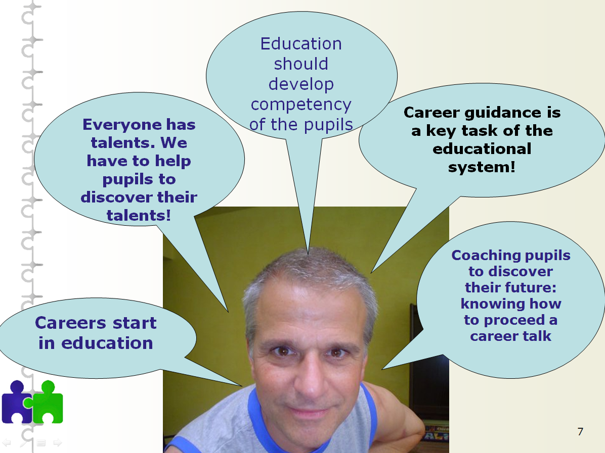

CLB-career guidance actions:
- Career information website: information about all existing fields of study:
- What? Where? Who is admitted? Which courses? Attestation? What can you study afterwards? Leading to what profession?

Career guidance tools to use in individual talks and in a class:

- Going from basic to secondary education
- Going from the first degree in secondary education to the second degree
- Going from secondary education to higher education

Specific for helping choose a higher education:
  - Questionnaire choosing-a-course task (online and in paper)
  - Portrait value questionnaire (paper)

Tools in cooperation with universities/academies and the flemish employment office
    - For example:
Pupils can explore their study efficiency in higher education, do they have enough pc-abilities, are they prepared for using and understanding some academic language

Stredná odborná škola technická- Slovakia

Career guidance through project work:

Project „VOCATIONAL EDUCATION AND PREPARATION FOR THE LABOUR MARKET“

Supported by The Program of Slovak-Swiss Cooperation

Main coordinator is ŠIOV (State Institute of Vocational Education) with The Office of the Government of Slovak Republic and Swiss Confederation

The aim of the project – development of cooperation between employers and vocational schools so that students of these schools would be able to place themselves at the labour market

The result will be:
- improvement of education
- improvement of graduates profile
- better opportunities at the labour market

The curricula will be updated and innovated according to the needs of employers. It will take into account not only current status and present situation but also their expectations for the future.

The problems are:
- Lack of students at vocational schools
- Lack of information for pupils of primary schools
- Lack of technical equipment
- Low interest of companies to involve in vocational training
- Curricula which are not always suitable according to requirements of the labour market.

The aim of project:
- To improve the quality of vocational education
- To get education closer to reality in companies
- To make technical education more attractive for parents and students
- To change attitude of parents and students to vocational education

Main activities:
- Methodological work on professional orientation of pupils for vocational education
- Creating of functional tool to identify potential orientation of pupils at the second level of primary schools
- Continual education of teachers
- Verifying of the use of potential orientation of pupils

Other activities:
- Excursions of primary schools pupils to vocational schools, firms and other institutions
- The open days at partner companies and schools
- Discussions
- Other forms of contact among pupils and representatives of the chosen professions
- Studying in the centres of vocational training equipped by the newest technology
- Practical training directly with the employer with salary
- Increasing number of training lessons

The result of activities:
- Possibility to sign a contract for the future employment during studies
- Higher possibility for graduates to assert themselves in the labour market
- Decreasing of unemployment of graduates from vocational schools
- Increasing of chance to work in the branch they have graduated from
- Closer cooperation between a student and a career councelor in professional orientation

